Special Population
Student’s Name
Institutional Affiliation

Part One
Voting is a civic process where citizens are given an opportunity to select leaders of their choice. The United States is recognized as one of the democracies where citizens are entitled to several rights and freedom. Voting is one of these rights. The 15th Amendment of the constitution recognizes the right to vote. It stipulates that citizens should not be denied their right to vote regardless of aspects such as color, past conditions, or race (Gooden & Faulkner, 2020). Therefore, the federal government must try as much as possible to secure this right. The 15th Amendment only emphasized men's voting rights. The 19th Amendment clearly defined women’s voting rights. There are other amendments, such as the 26th, that also touch on this voting right. Regardless of these voting rights, some special groups still encounter difficulties in exercising their voting rights. Individuals who are homeless are a special population who are victims of circumstance.
It is crucial to note that homelessness should not be considered as an automatic factor that disqualifies individuals from voting. Most people in this population fail to exercise their voting rights due to several barriers. One of these reasons is that these people do not have a permanent residency where they can easily access voting information through channels such as mailing (Lane & Pritzker, 2018). The majority of this population also lacks identification documents hence making it hard to vote. The resources that are required to educate these individuals on voting issues are also limited. Another issue is that homeless individuals are low-income earners. This means that they might lack adequate funds to facilitate their movements during electoral processes. Therefore, there is an urgent need to establish a voter education project for these homeless individuals.

Voter Education Project for Individuals who are Homeless
This project will incorporate several aspects in relation to voting with the aim of solving voting issues in this special population.
The following are key elements of this project:
- Educating this population on the eligibility for voter registration.
- Educating this population on how to register
- Conducting mobile voter education and registration in areas where this population resides.
- Providing this population with transport services to voter registration centers.
- Involving media outlets to educate this population on varied issues such as the importance of voting.
- Educating this population on various voting methods such as mail ballots and hand-marked ballots.
- Educating them on voting periods.

A Flyer for Sharing Information about their Voting Rights
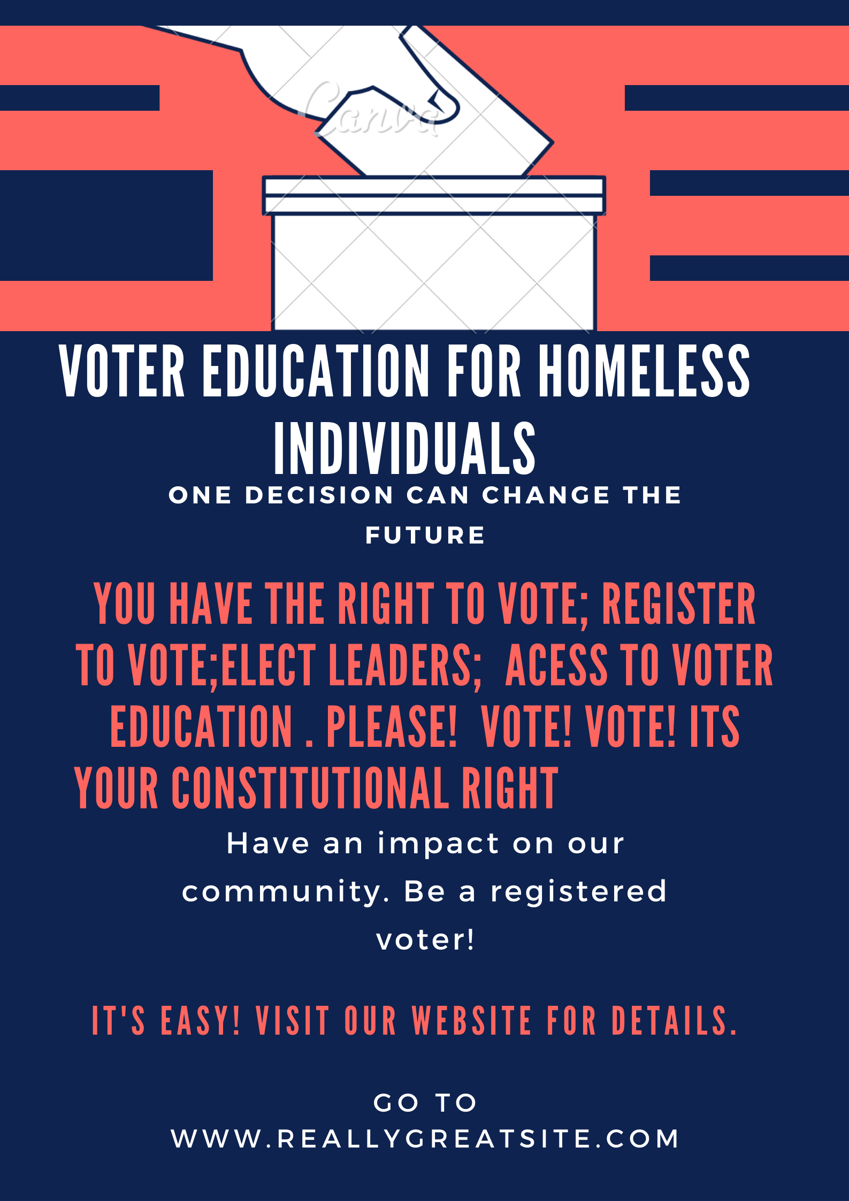
Part Two
Memo
Child poverty is one of the social problems from the policy priorities that are described by the Children’s Defense Fund. Child poverty connotes that children cannot afford or they lack access to basic needs such as food, water, shelter, clothes, and education, among others. One of the causes of this problem is the lack of unemployment. It is evident that these children live in poverty because their parents or guardians are unemployed hence lack adequate income to sustain their needs. Another cause is a disability. Some parents of these children are living with disabilities hence making it hard to work and earn a decent living. The potential policy solution to this problem is the creation of transitional jobs for these children's parents who are unemployed and underemployed. This will ensure that these parents sustain their children's needs since they can earn constant income. Another policy is raising the minimum wage as a way of increasing the wages and salaries of these individuals.

References
Gooden, S. T., & Faulkner, B. S. (2020). Social Equity and Voting Rights: A Shrinking Regime. In Ethics for Contemporary Bureaucrats (pp. 148-164). Routledge.
Lane, R.S., & Pritzker, S. (2018). Political Social Work: Using Power to Create Social Change. Springer

